**Emoji camera Sticker maker :**

Thanks for purchasing my product.

Author: passiontocode

Date: 15/3/2015

Please follow below steps to set up your and to upload on play store :

About this product:

-This product is developed in eclipse SDK. You can do any customization with the code.

- You will create new app in few minutes if you have basic knowledge of java programming.

- App is integrated with admob. Admob will help you to earn revenue.

<https://play.google.com/store/apps/details?id=com.rlapps.emoji.camera.sticker.maker>

<https://play.google.com/store/apps/details?id=com.candysmilestudio.emojicamerasticker>

<https://play.google.com/store/apps/details?id=com.appslyn.emojiphotosticker>

App Features :

-Splash screen.-Select image from camera/gallery.-more than 50 attractive Emojis/stickers.-Select Emojis/stickers to put on your images. -Zoom in/Zoom out, Rotate left/right with 2 fingures to adjust emojis.-Save Images in your Sd-Card.-Easy to customization.-Share images with any social app. -Admob banner/intersitials ads integrated. -Easy to customization.

1. How to import source code :

Please follow this video

<https://www.youtube.com/watch?v=Iw0VeDzR7Cg>

Please import 2 projects google play services and Emoji Camera Sticker Maker. Add google play services and aviary_SDK in your code.

Steps to add google play services :

Right click on photo hording project. Go to properties > android > click on add button. Choose google play services and apply it.

1. How to change admob id :

Go to res/values/Strings.xml

<string name=*"adUnitId_banner"*>ca-app-pub-2691806550199991/2260081868</string>

<string name=*"adUnitId_intersitial"*>ca-app-pub-2691806550199991/3736815064</string>

1. **How to change package name :**

Go to src/ com.waycreon.emojicamera you can put your company name for exa :

com.<company name>.waycreon.emojicamera

1. **How to change application name :**

Go to res > values > strings.xml

<string name=*"app_name"*>Emoji Camera Sticker Maker</string>

1. **How to change / Add emojis**

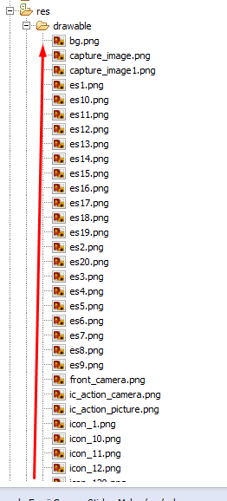

All images are in res/drawable folder.

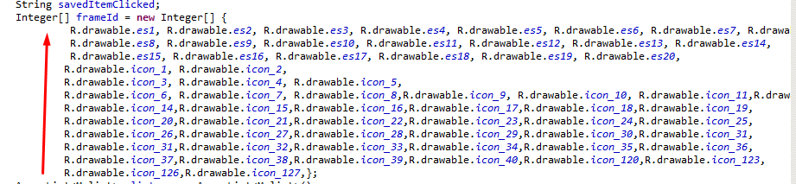

If you want to add more emojis, you just need to paste in drawable folder and define image name in MainActivity.java file Like above 2 images.

Important note : Please make sure image name only contain 0-9,a-z characters.

Thanks,

Passiontocode

**Thank You.**